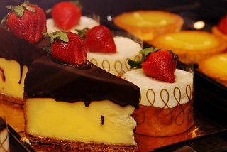Risher’s Sweet Treats

& Café
Menu
(not set in stone and subject to change)
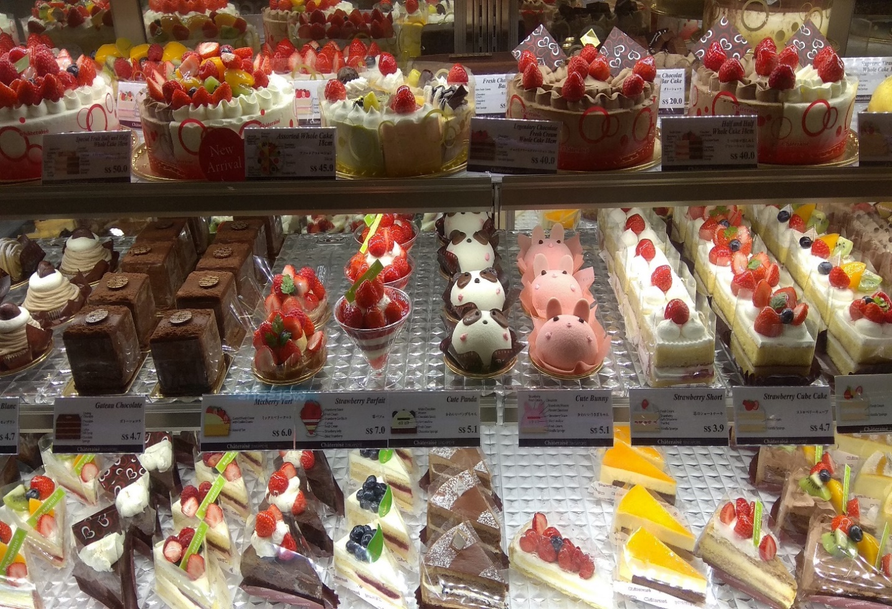
Heavenly Cakes: (For All Occasions)
Classic Chocolate, Vanilla, Marble, etc.-layers of moist cake topped with your choice of frosting, fillings are available upon request.
Red Velvet Delight-soft red velvet cake paired with cream cheese frosting.
Lemon Blueberry Drizzle Cake-tangy lemon cake filled with fresh blueberries and topped with a lemon glaze.
Pumpkin Crunch Cake (seasonal)-a delightful fusion of autumnal flavors, this cake features a velvety pumpkin base topped with a crispy, buttery crumble. The contrast between the soft, spiced pumpkin layer and the crunchy topping, often comprised of nuts, oats, and brown sugar, creates a harmonious medley of textures. Perfectly capturing the essence of fall, each bite transports you to a world of falling leaves and cozy sweaters.
Caramel Apple Crunch Cake (seasonal)-An ode to orchard-fresh apples, this cake layers sweet, tender apple slices with a drizzle of rich caramel sauce, all beneath a golden, crumbly topping. The sweet tartness of the apple pairs impeccably with the deep, buttery notes of the caramel. The crunchy layer, often infused with cinnamon and studded with nuts, adds a contrasting texture, making this cake the quintessential treat for crisp autumn days.
German Chocolate Cake-a rich, layered chocolate cake filled and topped with a gooey coconut and pecan frosting.
Pineapple Upside Down Cake-a retro classic that starts with caramelized slices of pineapple placed at the bottom of the pan, topped with a vanilla cake batter. Once baked and inverted, the cake reveals a beautiful, glistening pineapple pattern on top. Maraschino cherries often dot the center of each pineapple ring, adding a pop of color and sweetness. The caramelized fruit provides a sweet and tangy contrast to the soft, fluffy cake beneath.
Carrot Cake-a moist, spiced cake that beautifully melds the flavors of grated carrots, walnuts, and sometimes pineapples and raisins. Often paired with a luscious cream cheese frosting, this cake strikes a balance between sweetness and the earthiness of carrots. Topped with decorative piped carrots or crushed nuts, it’s a delightful treat that also boasts a hint of nutrition.

Cupcakes:
Red Velvet w/White Chocolate Cream Cheese Frosting-savor the irresistible charm of our Red Velvet Cupcakes, each one swathed in a luscious white chocolate cream cheese buttercream frosting. The rich, scarlet base with its velvety crumb offers a delicate cocoa note, providing a beautiful contrast to the creamy, melt-in-your-mouth frosting and filling. This indulgent frosting, with its heavenly blend of sweet white chocolate and tangy cream cheese, wraps each bite in a luxurious symphony of flavors that’s sure to enchant any dessert aficionado.
Peanut Butter Ganache filled Chocolate Cupcakes w/Peanut Butter White Chocolate Cream Cheese Frosting-dive into the decadent delight of our Chocolate Cupcakes, each one filled with a sumptuous peanut butter ganache that oozes with rich, nutty goodness at first bite. The dark, tender cake creates a perfect backdrop for the creamy, luscious filling. These indulgent treats are then topped with a swirl of Peanut Butter white chocolate cream cheese buttercream frosting, a silky and smooth embrace that perfectly complements the intensity of the chocolate and savory depth of the peanut butter. A true masterpiece of flavors and textures, these cupcakes are a dream come true for peanut butter and chocolate aficionados alike.
Vanilla Cupcakes w/Strawberry Buttercream Frosting filled with Strawberry Ganache-experience the sweet symphony of our Vanilla Cupcakes, where classic flavor meets a burst of berry bliss. Each cupcake is a light, fluffy canvas of pure vanilla goodness, creating a delicate base for the vibrant strawberry buttercream frosting that crowns these little delights. The frosting, whipped to airy perfection, is infused with real strawberry puree, granting it a fresh, fruity flourish that’s as delightful to the palate as it is to the eye. Hidden within, a luscious strawberry ganache filling awaits, its rich, velvety texture intermingling with the cupcake for an enchanting core of intensified flavor. Perfect for any occasion, these cupcakes are a celebration of the timeless pairing of strawberry and vanilla.
Chocolate Cupcake w/Chocolate Chip Mint Cream Cheese Buttercream Frosting Filled with Mint Ganache-indulge in the refreshing allure of our Chocolate Cupcakes with Mint Ganache, a confection that’s as invigorating as it is indulgent. Each Cupcake features a rich, moist chocolate base that serves as the perfect vessel for the cool, minty surprise nestled within a smooth and velvety mint ganache that melts enticingly on the tongue. Topping off this decadent treat, a swirl of mint cream cheese buttercream frosting provides a creamy contrast, its subtle tang and aromatic mint flavor pairing exquisitely with the deep chocolate notes. This mint-chocolate creation is a delightful twist on a classic, promising a satisfying finish with every mint-kissed bite.
Monster Cookie Cupcake w/a Marshmallow & M&M filling, Topped w/Buttercream Frosting w/crushed Oreo and Chips Ahoy cookies-feast your eyes on the Monster Cookie Cupcake, a playful indulgence that’s as fun to eat as it is to look at. This whimsical treat starts with a soft, fluffy cupcake base, reminiscent of your favorite monster cookie, as you delve deeper, you’re greeted by a creamy marshmallow filling with colorful M&M’s that provide a delightful sweet and gooey surprise w/a crunch and a pop of color that adds a layer of nostalgic comfort in every mouthful. The entire cupcake is generously frosted with a smooth, rich buttercream that melts seamlessly on the palate. This isn’t just any buttercream, though, it’s been speckled with crushed Oreos and Chips Ahoys, adding a cookie-and-cream twist that’s both texturally intriguing and irresistibly delicious. The crumbled cookie pieces scattered over the frosting not only add visual contrast with their dark and light crumbs against the creamy white but also a satisfyingly crunch finish. Each bite of this Monster Cookie Cupcake is a playful adventure, with bursts of chocolate, candy, and cookies in a symphony of sweet, decadent joy.
Cake Pops:
Classic Chocolate-rich chocolate cake crumbs mixed with velvety chocolate frosting, molded into bite-sized spheres, and coated with a glossy chocolate shell. A timeless treat that’s sure to satisfy any chocolate lover.
Red Velvet-a marriage of vibrant red cake and creamy cream cheese frosting, encased in a white chocolate coating. Its striking color contrast is as delightful to the eye as its flavors are to the palate.
Birthday Cake-vanilla cake combined with colorful sprinkles and buttercream frosting, enrobed in a pastel-colored candy coating. A whimsical treat that feels like a birthday celebration in every bite.
Cookies ‘n Cream-crushed chocolate sandwich cookies blended with cream-based frosting, dipped in white chocolate, and topped with cookie crumbles. A dream for cookies ‘n cream enthusiasts.
Lemon Bliss-zesty lemon cake mixed with tangy lemon frosting, cloaked in a lemon- infused white chocolate glaze. A refreshing burst of citrus in a petite treat.
Coconut Snowball-fluffy vanilla cake combined with coconut cream frosting, covered in white chocolate, and generously rolled in shredded coconut. A tropical escape in a bite.
Mocha Latte-chocolate coffee-infused cake blended with mocha frosting, dipped in milk chocolate, and topped with a drizzle of white chocolate. An energizing treat that coffee lovers will adore.
Salted Caramel Pretzel-caramel-infused cake mixed with caramel frosting, coated in milk chocolate, and sprinkled with crushed pretzels and a pinch of sea salt. A delightful play of sweet and salty.
Strawberry Shortcake-strawberry cake combined with a hint of vanilla frosting, enveloped in pink-tinted white chocolate, topped with golden cake crumbles. A berry-filled bite reminiscent of the classic dessert.
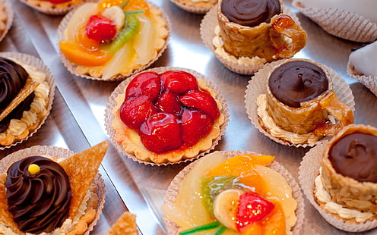
Pumpkin Spice-pumpkin cake spiced with cinnamon and nutmeg, blended with a cream cheese frosting, coated in white chocolate, and sprinkled with a touch of cinnamon sugar. A fall favorite that warms the soul.

Tantalizing Tarts:
Raspberry Almond Tart-combining the tartness of fresh raspberries with the nutty aroma of almonds, this tart features a raspberry layer atop an almond cream (frangipane), all encased in a buttery crust.
Salted Caramel Chocolate Tart-a sinful blend of layers, this tart combines the richness of chocolate with the deep, buttery notes of salted caramel. The sprinkle of sea salt on top elevates the flavors, making it a modern favorite.
Lemon Tart-a vibrant and zesty dessert, this tart features a silky lemon custard filling nestled in a buttery, crisp pastry shell. Often topped with a light dusting of powdered sugar or a brulee sugar crust, it delivers a harmonious balance of tart and sweet in every bite.
Chocolate Ganache Tart-pure indulgence, this tart boasts a rich, velvety chocolate ganache filling in a crumbly cocoa pastry crust. Often adorned with a sprinkle of sea salt or fresh berries, its decadence is perfect for any chocolate lover’s cravings.
Fruit Tart-a celebration of fresh produce, this tart is topped with a medley of vibrant, ripe fruits such as strawberries, kiwis, and blueberries, arranged atop a creamy custard or cream cheese filling, all encased in a golden pastry shell.
Pecan Tart-evoking the flavors of autumn, this tart is laden with caramelized pecans in a sticky, sweet filling. The crunchy texture of the nut’s contrasts beautifully with the soft filling and crisp pastry.
Tarte Tatin-a French classic, this upside-down tart showcases caramelized apples (or sometimes pears) that sit atop a layer of golden, flaky pastry. Once inverted, the fruit forms the top layer, shining in its caramel glaze.
Coconut Cream Tart-tropical and creamy, this tart is filled with a luscious coconut custard and often topped with whipped cream and toasted coconut flakes, offering a bite of paradise.
Blueberry and Lemon Cream Tart-a refreshing combination, this tart pairs the sweet, juicy burst of blueberries with a tangy lemon cream, creating a summery delight encased in a crisp crust.
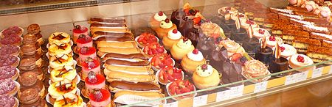
Savory Tomato and Goat Cheese Tart-venturing into the savory realm, this tart showcases ripe, juicy tomatoes and creamy goat cheese on a bed of caramelized onions, all nestled in a flaky pastry. Fresh herbs like thyme or basil often garnish the top.

Divine Pastries:
Strawberry Cream Eclairs-light choux pastry filled with strawberry cream and glazed with pink icing.
Chocolate Hazelnut Croissants-flaky croissants filled with chocolate hazelnut spread.
Croissant-this buttery, flaky pastry is the epitome of perfection when freshly baked. Its multiple layers, achieved through a process of lamination, turn golden brown and crisp on the outside, while remaining tender and airy inside.
Cannoli-tube-shaped shells of fried pastry dough, filled with sweet, creamy filling, typically made from ricotta. They can be adorned with chocolate chips, pistachios, candied fruits, or sprinkles.
Danish-a versatile pastry, it comes with various fillings such as fruit preserves, custard, or almond paste. Its buttery layers often have a slight sweetness and can be topped with icing or almonds.
Chocolate Éclair-a cylindrical choux pastry filled with cream (often flavored) and topped with glossy chocolate glaze. The contrast between the soft filling and firm outer layer makes for an indulgent experience.
Tiramisu Pastry Cups-a twist on the traditional Italian dessert, these cups layer mascarpone cheese, coffee-soaked sponge fingers, and cocoa or grated chocolate in a delicate pastry shell, offering a bite of heaven.

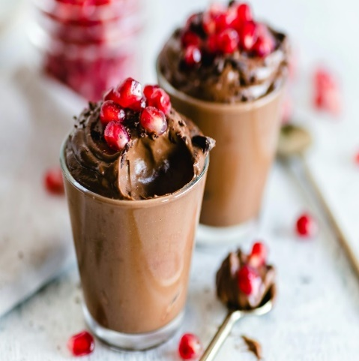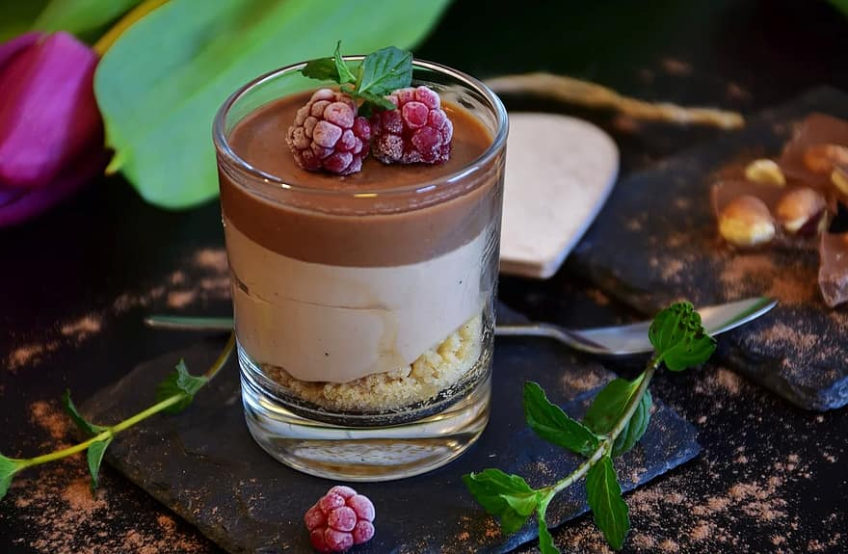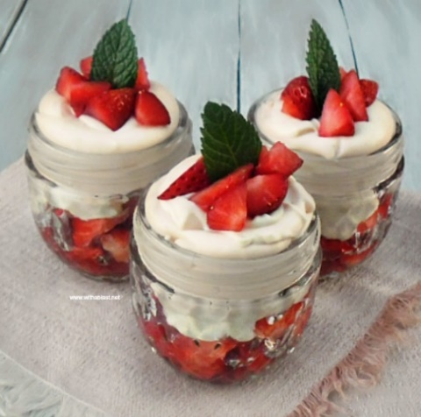
Chilled Desserts:
Pumpkin Mousse-layers of pumpkin mousse topped with freshly whipped cream.
Triple Chocolate Mousse-layers of dark, milk and white chocolate mousse topped with chocolate shavings.
Strawberry Mousse Parfait-layers of velvety strawberry mousse, delicate crumbs of buttery biscuit, topped with freshly whipped cream and strawberry slices.
Tiramisu-an Italian classic, tiramisu layers coffee-soaked lady fingers with a luscious mascarpone cheese mixture. Dusted with cocoa powder, this dessert offers a harmonious blend of creamy richness and the invigorating touch of espresso.
Cheesecake-creamy, dense cake made from a mixture of cheese (often cream cheese), sugar, and eggs. With a crumbly crust, often made of graham crackers or biscuits, and various toppings, it’s a versatile dessert loved globally.
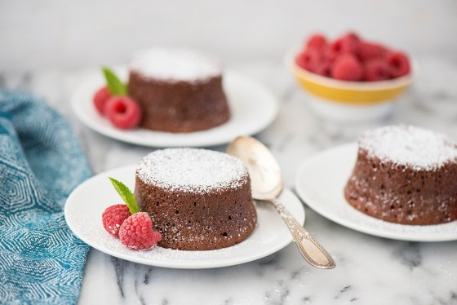
Trifle-layers of sponge cake, fruit, custard, and whipped cream. Some versions include sherry-soaked cake or jelly (gelatin) layers. Served in a large glass dish, it’s as much a visual treat as a gustatory one.
Warm Indulgences:
Apple Cinnamon Crumble-tender baked apples with a cinnamon crumble topping, served with vanilla ice cream. (can also be made with peaches)
Apple Crisp-tender baked apples, often spiced with cinnamon, lie beneath a crunchy topping of oats, butter, and sugar. Warm from the oven, it pairs perfectly with a scoop of vanilla ice cream.
Molten Chocolate Lava Cake-a gooey, molten chocolate center that oozes out upon the first forkful. Best served fresh from the oven, it’s a chocolate lover’s dream.
Bread Pudding-a classic comfort dessert, bread pudding takes cubes of stale bread and soaks them in a luscious custard mixture. Baked until golden and often served with a drizzle of caramel or vanilla sauce, it’s the epitome of homely sweetness.
Bananas Foster-this flamboyant dessert features bananas sauteed in a mixture of butter, brown sugar, cinnamon, and dark rum. The rum is often flambeed, creating a spectacular display before it’s swerved over vanilla ice cream.
Cinnamon Rolls-soft, fluffy dough swirled with a mixture of cinnamon, butter, and sugar, these rolls are baked to perfection and often topped with a luscious cream cheese glaze. Warm and aromatic, they’re perfect for both breakfast and dessert.
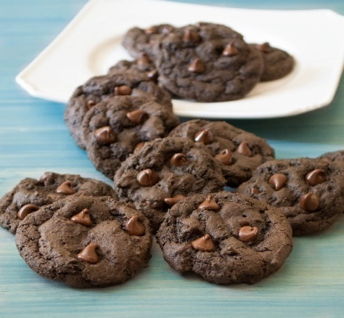
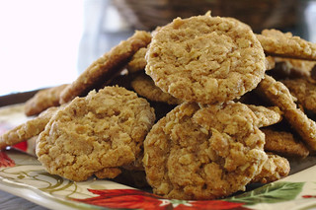
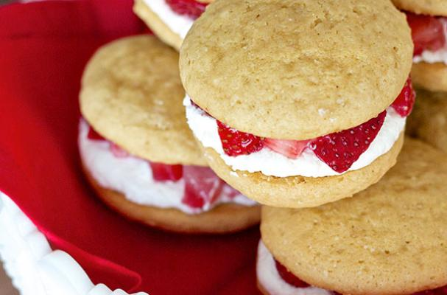
Peach Cobbler-juicy peaches, often spiced and sweetened, form the base, while dollops of biscuit dough or a batter create a golden, crusty top. This Southern favorite, served warm, brings summer flavors to any table.
Classic Cookies:
Chocolate Chip Cookie Bliss-soft-centered cookies loaded with chocolate chips.
Oatmeal Raisin Comfort-chewy oatmeal cookies with plump raisins.
White Chocolate Macadamia Dream-crunchy cookies with chunks of white chocolate and macadamia nuts.
Whoopie Pies-your choice of vanilla, chocolate, pumpkin, red velvet, oatmeal, or snickerdoodle cookie filled with a delicious, whipped cream/buttercream/cream cheese filling.
Macarons-these delicate sandwich cookies consist of two almond meringue shells filled with ganache, buttercream, or jam. They come in a rainbow of colors and variety of flavors.
Snickerdoodles-a soft, buttery cookie rolled in cinnamon sugar, with a characteristic crinkled surface and tangy flavor from the cream of tartar.
Strawberry Cheesecake Cookies-a delightful fusion of classic cheesecake and cookie elements. With a chewy base reminiscent of graham crust, these cookies are dotted with juicy strawberry pieces and have a creamy undertone from incorporated cream cheese. Each bite offers a harmonious blend of tangy cheesecake richness and fresh strawberry sweetness.
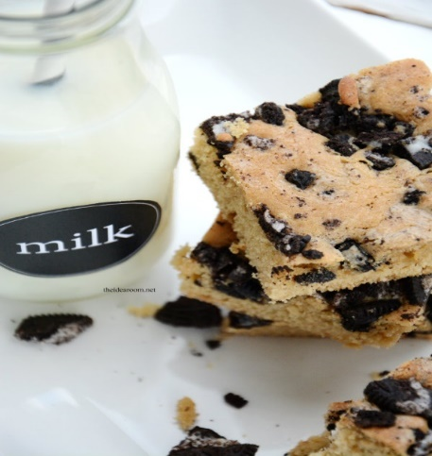
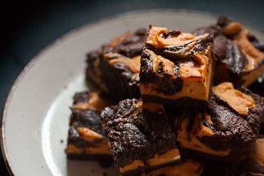
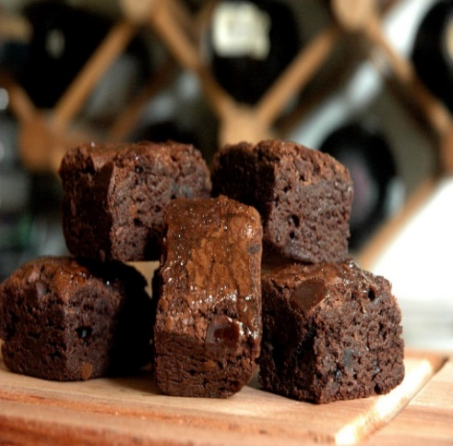
Brownies:
Fudgy Brownies-deep, dense, and rich with an intense chocolate flavor.
Cakey Brownies-crumbly, cake like texture for those who prefer a less dense brownie experience.
Chewy Brownies-striking the balance between fudgy and cakey, chewy brownies boast a dense texture that offers a delightful resistance when bitten into.
Blondies or Blond brownies-ditching the cocoa, blondies take on a vanilla or butterscotch flavor profile, often enhanced with chunks of white chocolate, nuts, or dried fruits. Their gold hue and sweet, caramel-like taste make them a delightful alternative to traditional brownies.
Nutty Brownies-enriched with the crunch and flavor of walnuts, pecans, or almonds, nutty brownies offer a delightful contrast of textures.
Swirl Brownies-a beautiful blend of brownie batter with additions like caramel, peanut butter, or cream cheese, creating a visually striking and deliciously multifaceted treat.
Mint Chocolate Brownies-a refreshing twist on the classic, these brownies layer or mix in mint-flavored chocolate or frosting, giving a cool aftertaste.
Espresso Brownies-infused with finely ground espresso or strong brewed coffee, these brownies offer a robust depth of flavor. The bitterness of the coffee enhances the chocolate’s richness, making it a favorite for coffee lovers.
Salted Caramel Brownies-drizzled or layered with gooey caramel and sprinkled with a touch of sea salt, these brownies are the perfect marriage of sweet and salty. The caramel not only adds sweetness but also a sticky, delightful texture.

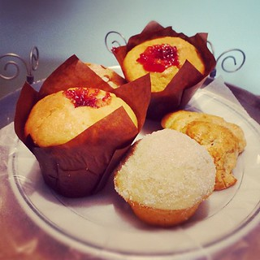
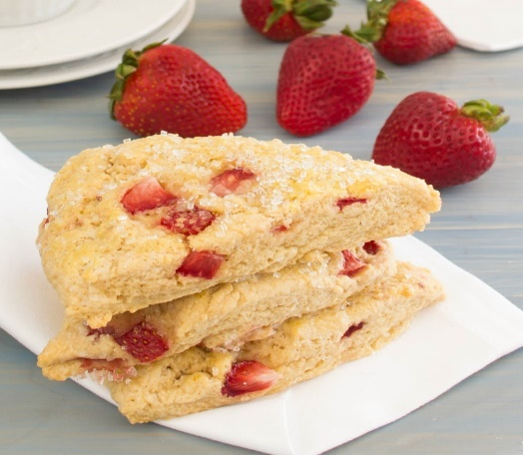
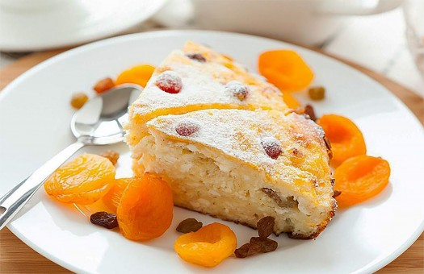
Freshly Baked Muffins and Scones:
Muffins:
Blueberry Muffins-a breakfast classic, these muffins burst with the juiciness of fresh or frozen blueberries. The soft, golden batter complements the tartness of the berries, making for a delightful morning treat or afternoon snack.
Banana Nut Muffins-packed with the natural sweetness of ripe bananas and the crunch of walnuts or pecans, these muffins are moist, flavorful, and perfectly comforting.
Chocolate Chip Muffins-soft, fluffy, and dotted with semi-sweet chocolate chips, these muffins are a chocolate lover’s dream, turning any moment into a special occasion.
Lemon Poppy Seed Muffins-zesty and aromatic, these muffins combine the brightness of lemon with the subtle crunch of poppy seeds for a light and refreshing taste.
Bran Muffins-a fiber-rich option, these muffins are made with wheat bran, offering a denser texture and a wholesome, earthy flavor, often enhanced with raisins.
Scones:
Classic Cream Scones-rich and buttery, these traditional scones have a crumbly exterior and a soft, tender center. Often enjoyed with clotted cream and jam, they’re a staple in many afternoon tea spreads.
Cranberry Orange Scones-a delightful blend of tangy cranberries and zesty orange zest, these scones offer a refreshing burst of flavor in every bite.
Cheddar and Chive Scones-moving to the savory side, these scones combine the sharpness of cheddar with the mild onion flavor of chives. Perfect as a side for soups or salads.
Cinnamon Raisin Scones-warm and comforting, these scones are studded with plump raisins and swirled with cinnamon, evoking the coziness of a hearty breakfast.
Lavender and Honey Scones-delicately floral with a touch of sweetness, these scones are infused with dried lavender and drizzled with hone, creating an elegant flavor profile.

*All cakes, cookies and brownies can be made Gluten Free.
*If there is a request not on the Menu, it can still be made.
*Menu is subject to change as new ideas surface.

